Develop a vb project to design a simple calculator using control array

Form design:

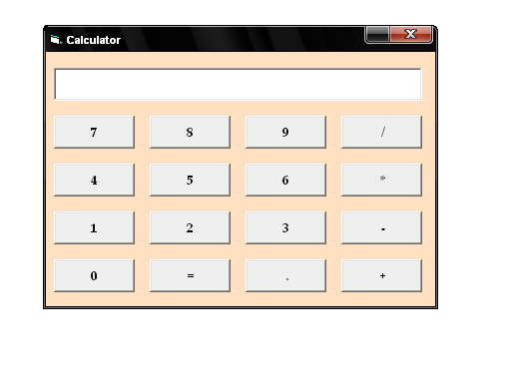
Properties:

Controls | Name | Caption
Text1 | Text1
Command1 | Cmdnumber
Command2 | Cmdplus | +
Command3 | Cmdsubtract | -
Command4 | Cmdmultiply | *
Command5 | Cmddivide | /
Command6 | Cmddot | .
Command7 | Cmdequal | =

10.Simple Calculator
Aim:
To develop a vb project to design a simple calculator using control array

Coding:
Dim a, t, a1 As Integer

Private Sub Cmdnumber_Click(Index As Integer)
Text1.Text = Text1.Text + Command1(Index).Caption
End Sub

Private Sub Cmddivide_Click()
t = 4
a = Val(Text1.Text)
Text1.Text = " "
End Sub

Private Sub Cmdmultiply_Click()
t = 3
a = Val(Text1.Text)
Text1.Text = " "
End Sub

Private Sub Cmdsubtract_Click()
t = 2
a = Val(Text1.Text)
Text1.Text = " "
End Sub

Private Sub Cmdadd_Click()
t = 1
a = Val(Text1.Text)
Text1.Text = " "
End Sub

Private Sub Cmddot_Click()
Dim y As Integer
y = InStr(Text1.Text, ".")
If (y > 1) Then
MsgBox ("Not allowed here!")
Else
Text1.Text = Text1.Text + "."
End If
End Sub

Private Sub Cmdequal_Click()
a1 = Val(Text1.Text)
Text1.Text = " "
Select Case t
Case 1
Text1.Text = a + a1
Case 2
Text1.Text = a - a1
Case 3
Text1.Text = a * a1
Case 4
Text1.Text = a / a1
End Select
End Sub

Output:

